**Boarding Time Relaxation**

***Work-flow to Use Boarding Time Relaxation***

There is currently one Optibus template



Use **Load Template** to set up the preference



Repeat **Load Template** for additional instances of the template



***Preference Overview***

A provision for boarding time may be made in the customer schedule data. Here we allow for the possibility of reducing it at the expense of a sliding penalty that increases with the reduction of a scheduled trip boarding time. If boarding time is defined, it will appear in the relevant vehicle information box:

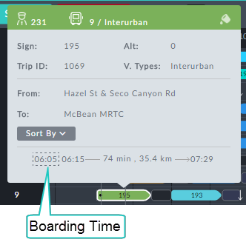

In the example, the boarding time extends the scheduled trip time by 10 min.

***Templates Available from Optibus***

***Boarding Time Relaxation***

**Purpose:**

Sets the penalty for relaxing the boarding time.

**Prerequisites:** The boarding time must be defined in the Dataset for the schedule.

**Opening Dialog:**

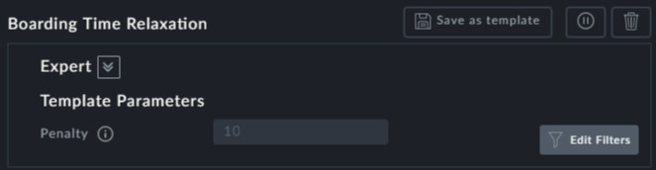

*Figure 1-1: Boarding Time Relaxation preference*

**Points to note:**

The only entry field here is the opening penalty. It increases nearly linearly with boarding time violation.